Indira Gandhi Centre for Atomic Research

Department of Atomic Energy

Kalpakkam, India

**Progress Report on**

**IAEA CRP**

**Radioactive Release from the Sodium Cooled Fast Reactor**

**Under Severe Accident Conditions**

**May 2017**

**Table of Contents**

|  |  |
| --- | --- |
| **Summary** |  |
| **1. Introduction and background** | 4 |
| **2. Research Objective and Scope** | 4 |
| **3. Description of the Reference Sodium Cooled Fast Reactor** | 6 |
| 3.1 Geometrical features and dimensions of reactor core and internal structures | 8 |
| * 1. Top Shield | 11 |
| * 1. Reactor Containment Building | 17 |
| * 1. Radio Nuclide Inventory | 19 |
|  |  |
| **4. CDA Scenario Considered** | 23 |
| 4.1Degraded core data | 23 |
| 5. Simplified model for RCB source term estimation |  |
| 6. |  |

**1.0 Introduction and background**

In a typical medium to large sized pool type Sodium cooled Fast Reactor (SFR), hypothetical Core Disruptive Accident (CDA), is the Beyond Design Basis Event resulting from the mismatch of power produced and power removed from the reactor and the shutdown system not responding on demand, typically under conditions of either unprotected loss of flow or unprotected transient over power events. The consequent thermal energy release has an equivalent mechanical work potential, usually in the range of few to hundreds of MJ during which high temperatures and high pressure are reached. Though the accident is BDBA, Reactor Containment Building (RCB) is provided to mitigate the consequences of CDA and to ensure that the dose rate at the site boundary is within the prescribed limit.

The consequences of CDA in terms of radioactivity release to outside the containment system which may affect the environment and the public is of paramount importance from public acceptance point of view especially after the Fukushima event. Even though structural integrity of the primary vessel can be ensured by way of demonstrating its capability to withstand high mechanical energy, the pressure developed within the vessel during a CDA can lead to sodium release to RCB through several potential leak paths in the top shield structure of the reactor as shown in the schematic figure. The ejected sodium can burn inside RCB leading to temperature and pressure build up. The sodium release to RCB would also be accompanied by radioactive fission products and fuel that have come out of the failed pins. Fission products can leak to the environment through the leak paths in RCB.

The spread of the activity and dose rates at the site boundary and habitability of the control room need to be evaluated so as to provide sufficient design measures to protect the public from the consequences and to ensure that the dose rate exposure is within the design basis limits, which is important in the domain of safety.

This requires a good understanding of the whole phenomena under a severe accident scenario. Towards this, it is essential to precisely estimate the radioactivity source term, by modeling the phenomena of the mechanism of transport of fission products involving core bubble expansion characteristics, heat transfer interaction among core materials, sodium & cover gas, chemical interaction between fission products and sodium etc and to characterize the parameters influencing the fission product retention and ejection.

**2.0 Research Objective and Scope:**

The scope of the CRP is to perform realistic estimations of fission product and fuel particle inventory inside some specific SFR reactor areas (i.e. in-primary vessel, cover gas system and in-containment building as shown in Fig.1) at different time scales (few seconds for the instantaneous source terms and several days for the long term source term), under severe accident conditions. The objective is to improve the understanding of the key phenomena involving radioactive material transport inside the reactor vessel and the containment compartments, in order to reduce uncertainties in estimation of the releases to the environment under severe accident condition in SFR. Therefore, this CRP will contribute to extend the predictive capabilities of existing simulation tools devoted to SFR design and safety analysis.

**Fig.1:** Schematic depicting reactor volumes involved in the source term analysis.

**2.1 Scope of Analysis:**

1. In-vessel source term estimation
2. Primary system/containment system interface source term estimation
3. In-containment phenomenology analysis

**2.2 Input Data Identified for the Exercise:**

1. Dimensions and geometrical features of essential reactor structures such as the primary vessel and top shields
2. Total core inventory and fraction of molten fuel and vaporized fuel
3. Initial core bubble volume, pressure and temperature
4. Whole core average burn up
5. Sodium inventory within the vessel and initial sodium temperature
6. Primary vessel cover gas volume
7. Gross volume details of reactor internals
8. Penetrations and the leak paths in the reactor top shield structure for an idealized geometry

**3.0 Description of the Reference Sodium Cooled Fast Reactor**

The flow sheet of a typical 1250 MWt, 500 MWe sodium cooled pool type fast breeder reactor is shown in Fig. 2. Schematic section of reactor assembly section through pump and intermediate heat exchanger is shown in Fig. 3a and a top view is shown in Fig. 3b. The reactor consists of a primary sodium circuit, two secondary sodium circuits and a steam water circuit. Primary sodium circuit consists of core, control plug, hot pool, cold pool, two primary sodium pumps, four Intermediate Heat Exchangers (IHX), and Safety Grade Decay Heat Removal System (SGDHRS) etc. Primary sodium pumps (PSP) take sodium from the cold pool, pumps to the grid plate. Grid plate (GP) supports all the subassemblies (SA) and distributes sodium to them. Primary sodium while passing through these SA pickup heat and become hot. The hot sodium coming out of the SA mixes in the hot pool and enters the IHX. The hot sodium while passing through the IHX looses its heat to the secondary sodium and becomes cold. The cold primary sodium coming out of the IHX mixes in the cold pool. Finally the secondary sodium transfers heat to the steam-water system.

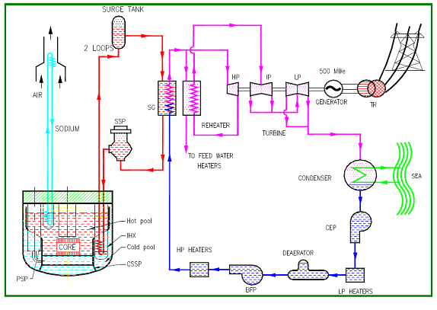

**Fig. 2: Flow sheet of 500MWe SFR**

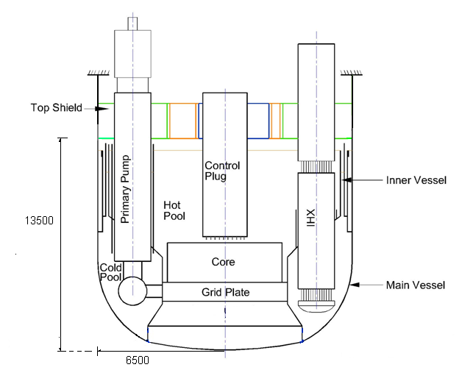

**Fig.3a: Schematic of Reactor Assembly Section through IHX and PUMP**

**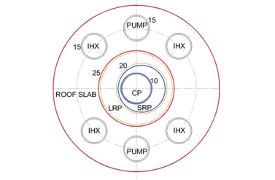**

**Fig.3b: Schematic of Reactor Assembly Top View**

**3.1 Geometrical features and dimensions of reactor core and internal structures**

All dimensions are given at room temperature. SA dimensions are given for fresh core (before irradiation).

The reactor assembly components are shown in Fig. 3a.

No. of intermediate heat exchangers (IHX) = 4

No. of primary sodium pumps (PSP) = 2

Pitch circle diameter of IHX and PSP = 9.8 m

The dimensions of the important immersed structures in the Main Vessel are given below in Table 1.

**Table 1: Important immersed structures in hot pool**

|  |  |  |  |  |
| --- | --- | --- | --- | --- |
| Sl. No. | Component | Diameter, m | Length, m  (Suspended from Roof Slab) | Number |
| 1 | Pump | 2.0 | 5 | 2 |
| 2 | IHX | 2,0 | 5 | 4 |
| 3 | DHX | 0.5 | 4.0 | 4 |
| 4 | DND | 0.35 | 1.5 | 8 |
| 5 | Control plug | 2.25 | 5 | 1 |

The hot pool and cold pool are separated by a thin vessel known as inner vessel (IV). The IV consists of two cylindrical shells of different diameters joined by a conical shell called redan. Control plug (CP) is located at the center of the hot pool above the core and is supported on the small rotating plug of the top shield. It houses 25 vertical cylindrical canals used as passages for control rod drive mechanisms, thermocouples and failed fuel location modules.

The reactor core consists of various types of subassemblies such as fuel, shield and reflectors. Schematic of fuel and blanket SA are shown in Figs. 4a and 4b respectively. They are arranged in a hexagonal layout as shown in Fig. 5. In order to achieve nearly uniform temperature at the outlet of each and every subassembly, dual enriched fuel zone and flow zoning is considered. The inner core has lesser fissile content compared to the outer core. The flow zoning in the core is achieved by providing orifices of varying resistances at the inlet of subassembly. The nominal core inventory is given in Table 2.

**Table 2: Nominal Core Inventories**

|  |  |  |  |
| --- | --- | --- | --- |
| **Material** | **Inner core FSA (kg)** | **Outer core FSA (kg)** | **Nominal Reactor Loading (kg)** |
| UO2 (active core) | 40.0 | 36.7 | 6923 |
| UO2 (ax. blanket) | 33.0 | 33.0 | 5973 |
| PuO2 | 10.5 | 14.0 | 2236 |

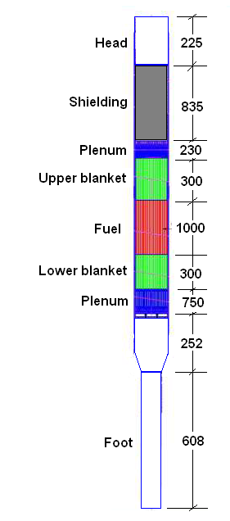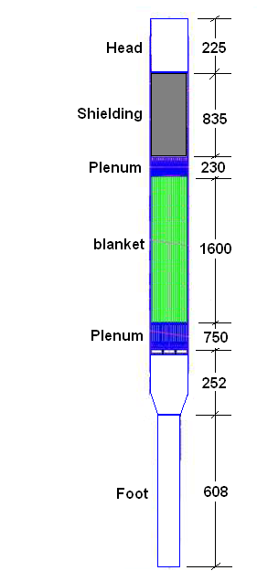

**Fig. 4b Schematic of Blanket SA**

**Fig. 4a Schematic of Fuel SA**

Oxide Fuel – Fissile Fractions 21% and 28%

Total height of SA = 4.5 m

Active core height = 1 m (Fig. 4)

Width across flats of SA = 131.6 mm (Max), 131.3 (Nominal)

Triangular pitch of the SA = 135 mm

Total core volume= 3000 litres (The core-1 and core-2 volumes being 1400 l*l* and 1600 l*l* Respectively)

Core 1 and Core 2 Peak Burn up**:** 100 and 90 MWd/kg

Sodium Inventory in Main Vessel: 1150 t

Primary Cover Gas Volume: 120 m3

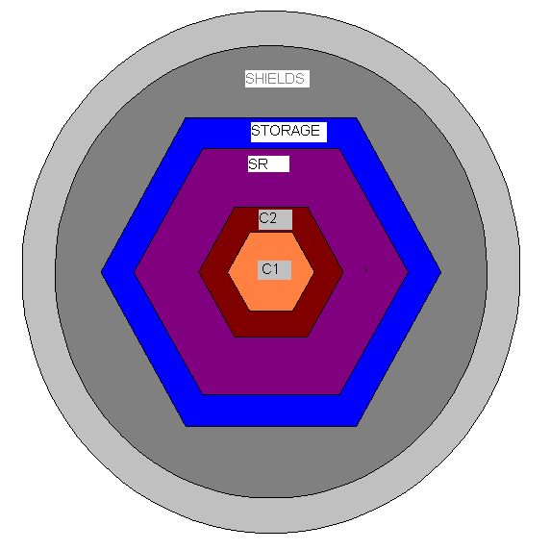

**Fig. 5: Core Configuration**

C1 and C2 – Core 1 and Core 2 (5+3 rows) = 180 FSA

SR – Steel Reflector (4 rows)

STORAGE – (2 rows)

SHIELDS – (9 rows)

**3.2 Top Shield**

Schematic of top shield is shown in Fig. 6. The major leak paths in the top shield are the annular gaps between the Roof Slab (RS) and Large Rotating Plug (LRP) and LRP and Small Rotating Plug (SRP). The other penetrations in the RS are passage for IHX, Primary Sodium Pumps, DHX, In Vessel Transfer Post cum Periscope access, Hot Pool Level Detector (HPLD), Cold Pool Level Detector (CPLD), Delayed Neutron Detector (DND), Sodium Fill and Drain Lines, Argon Feed and Outlet Lines, Sodium Purification Lines and Inclined Fuel Transfer Machine (IFTM). The penetrating paths in the SRP are due to Control Plug, Oval Shield Plug of Transfer Arm and Guide Tube of Transfer Arm. Control plug has penetrating paths due to Control and Safety Rod Drive Mechanisms (CSRDM), Diverse Safety Rod Drive Mechanisms (DSRDM), Failed Fuel Location Modules (FFLM), Thermocouples penetrations and Central Canal Plug.

All the components are very large and are secured with adequate number of bolts, with good redundancy. Hence, no ejection of any component is considered. The leak paths are only due to extension of the bolts. Number of bolts is large (~150). Even if 1 or 2 bolts is not secured properly, the effect is negligible on sodium release. Rupture of pipe lines is not postulated as the lines are designed for static equivalent of dynamic pressure under CDA. Accordingly, no leakage is expected through the sodium fill and drain lines, sodium purification lines and argon feed and outlet lines. In spite of this, it may be highlighted that any possible leaks through the sodium purification lines and the argon feed and outlet lines would reach the respective cells and not the RCB. Also, the sodium flow through these lines would be small owing to the short time duration of the phenomenon (~1 s) and longer lengths of these lines. The sodium leaks through thermocouple penetrations and central canal plug are expected to be very small since they are provided with tight fits.

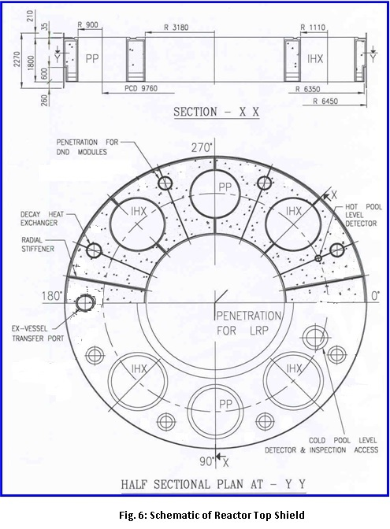

The major leakage paths RS-LRP and LRP-SRP consist of two branches, as can be seen in Figs. 7a and 7b. The first one is below the hold down ring while the second one is through support ring, bearing support ring and bearing. The schematic of leak paths in other components mounted over roof slab are shown in Figs. 7c to 7f.

**Fig. 7a: Schematic of LRP - Roof slab**

**leak paths**



**Fig. 7b: Schematic of the SRP - LRP**

**leak paths**



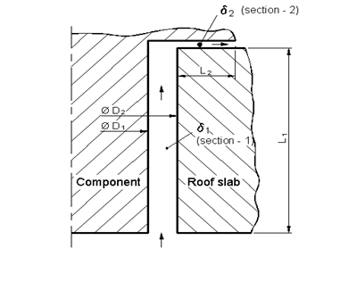

|  |  |  |  |  |  |  |
| --- | --- | --- | --- | --- | --- | --- |
| **Annular Path** | **D1**  **m** | **D2**  **m** | **δ1**  **m** | **L1**  **m** | **L2**  **m** | **δ2**  **mm** |
| RS-IHX | 2.18 | 2.2 | 0.02 | 1.8 | 0.06 | 0.5 |
| RS-PUMP | 2.18 | 2.2 | 0.02 | 1.8 | 0.06 | 0.5 |
| RS-DHX | 0.56 | 0.58 | 0.01 | 1.8 | 0.06 | 0.5 |
| RS-Fuel Transfer Port | 0.56 | 0.58 | 0.01 | 1.8 | 0.14 | 0.5 |
| RS- Hot Pool Level Detector | 0.18 | 0.2 | 0.01 | 1.8 | 0.12 | 0.5 |
| RS-Cold Pool Level Detectotr | 0.68 | 0.7 | 0.01 | 1.8 | 0.15 | 0.5 |
| RS-DND | 0.33 | 0.35 | 0.01 | 1.8 | 0.14 | 0.5 |
| RS-Fuel Transfer Machine bottom Flange | 0.56 | 0.58 | 0.01 | 1.8 | 0.14 | 0.5 |

**Fig. 7c: Dimensions of sodium leak paths in the roof slab**



**Fig. 7e: Schematic of Control plug- Absorber Rod Drive Leak Paths**



**Fig. 7d: Schematic of SRP – Fuel Handling Machine**

**Leak Paths**



**Fig. 7f: Schematic of Control plug – Failed Fuel**

**Identification Module leak paths**

* 1. **Reactor Containment Building**

35

40

7

18

CELLS

55

22

18

4

Enclosure above Roof Slab

(not leak tight)

MV & Reactor Vault

Roof slab

18

Argon

Buffer

Tanks

CORE

**Fig. 8: Sketch of RCB Showing Volumes for RCB Pressure and Radiation Release Calculations: Filled and Patterned volumes to be excluded. The unit is in meters.**

RCB

**Fig. 9: RCB plan View at 18m height Showing Reactor Vault and Major Cell Area**

The RCB free volumes are sketched in Fig. 8 and Fig, 9. The unit is in meters. The plan view of the cells within the RCB above roof slab level (floor level) is shown in Fig. 9. The cells mainly contain cover gas systems. Above roof slab a working platform is provided at a height of 4 m. This platform is not leak tight around pipe and equipment penetrations. Effective area of opening in the platform is 5 m2. The RCB volumes below roof slab level are not (conservatively) considered for expansion and deposition of radioactivity although they are connected by openings for stair ways and cable/piping ducts.

The cover gas systems are housed inside the RCB cells and finally paths exist for the exhaust of purified and delayed effluents to be vented through stack. The effective area available for leak through the top shield is comparatively much larger than the flow path available through cover gas argon circuit (pipe dia 10 cm and many filters and tanks in the flow path), the cover gas circuit need not to be considered for the first phase of the analysis.

**RCB Data**

Length = 40 m

Breadth = 35 m

Height above roof slab level 55m

Height below roof slab level 18 m

Rectangular Cell RCB above roof slab level

Length = 7 m

Breadth=18 m

Height = 22 m

Platform above roof slab at 4.0 m height, diameter 18m

RCB total volume = 77000 m3

RCB available volume = 74000 m3

**3.4 Radio Nuclide Inventory**

The radionuclide inventory (in Bq) of important fission product isotopes is given in Table 2 and for Actinides in Table 3. The data corresponding to three cases, viz., MOEC, EOEC and 100GWd/t burnup cases are given in the tables. Since there are 180 fuel assemblies, the activities for the three cases are obtained as follows.

A100GWd/t (Bq)= 180 x A100GWd/t

AEOEC(Bq) = 60 x A3 (540) + 60 x A2 (360)+60 x A1 (180)

AMOC (Bq)= 60 x A2.5 + 60 x A1.5 +60 x A0.5

**Table 3:Fission Product Inventory in the Core**

|  |  |  |  |  |
| --- | --- | --- | --- | --- |
| **Radionuclide** | **Half life** | **Core Inventory (Bq)** | | |
| **MOEC** | **EOEC** | **100 GWd/t** |
| I-131 | 8.02d | 1.46E+18 | 1.47E+18 | 1.48E+18 |
| I-132 | 2.30h | 1.94E+18 | 1.94E+18 | 1.96E+18 |
| I-133 | 20.80h | 2.51E+18 | 2.51E+18 | 2.54E+18 |
| I-134 | 52.50m | 2.50E+18 | 2.50E+18 | 2.53E+18 |
| I-135 | 6.57h | 2.21E+18 | 2.21E+18 | 2.23E+18 |
| Cs-134 | 754.50d | 5.19E+16 | 6.72E+16 | 9.65E+16 |
| Cs-137 | 30.07y | 4.98E+16 | 6.63E+16 | 1.00E+17 |
| Rb-88 | 17.78m | 5.17E+17 | 5.17E+17 | 5.22E+17 |
| Ru-103 | 39.26d | 2.22E+18 | 2.35E+18 | 2.41E+18 |
| Ru-106 | 373.59d | 6.16E+17 | 7.76E+17 | 1.06E+18 |
| Sr-89 | 50.53d | 6.31E+17 | 6.84E+17 | 7.12E+17 |
| Sr-90 | 28.79y | 1.43E+16 | 1.91E+16 | 2.88E+16 |
| Ce-141 | 32.50d | 1.98E+18 | 2.07E+18 | 2.11E+18 |
| Ce-144 | 284.89d | 6.37E+17 | 7.91E+17 | 1.05E+18 |
| Te-131m | 30.00h | 1.61E+17 | 1.61E+17 | 1.63E+17 |
| Te-132 | 3.20d | 1.86E+18 | 1.86E+18 | 1.88E+18 |
| Ba-140 | 12.75d | 1.91E+18 | 1.91E+18 | 1.93E+18 |
| Zr-95 | 64.02d | 1.49E+18 | 1.65E+18 | 1.76E+18 |
| La-140 | 1.68d | 1.94E+18 | 1.94E+18 | 1.96E+18 |
| Kr-85 | 10.70y | 2.36E+15 | 3.13E+15 | 4.69E+15 |
| Kr-85m | 4.48h | 2.24E+17 | 2.24E+17 | 2.26E+17 |
| Kr-87 | 76.30m | 4.04E+17 | 4.04E+17 | 4.08E+17 |
| Kr-88 | 2.84h | 4.89E+17 | 4.89E+17 | 4.94E+17 |
| Xe-133 | 5.24d | 2.52E+18 | 2.52E+18 | 2.55E+18 |
| Xe-135 | 9.14h | 2.63E+18 | 2.63E+18 | 2.66E+18 |

**Table 4: Actinide Inventory in the Core**

|  |  |  |  |  |
| --- | --- | --- | --- | --- |
| Nuclide | Half life | Activity (Bq) | | |
| MOEC | EOEC | 100 GWd/t |
| U237 | 6.75d | 1.37E+17 | 1.39E+17 | 1.46E+17 |
| Np238 | 2.12d | 2.80E+16 | 3.60E+16 | 5.39E+16 |
| Np239 | 2.35d | 2.53E+19 | 2.53E+19 | 2.59E+19 |
| Pu239 | 24400y | 2.38E+15 | 2.30E+15 | 2.17E+15 |
| Pu240 | 6561y | 3.68E+15 | 3.74E+15 | 3.87E+15 |
| Pu241 | 14.32y | 3.08E+17 | 3.03E+17 | 2.95E+17 |
| Cm242 | 162.8d | 3.51E+16 | 4.89E+16 | 8.16E+16 |
| Cm244 | 18.1y | 9.40E+14 | 1.42E+15 | 2.70E+15 |

**Table 5: Residual Power for Peak Burn up**

|  |  |  |  |
| --- | --- | --- | --- |
| Cooling  Period | Residual Power | MOEC | EOEC |
| Core | Core |
| 0 | - | 80.15 | 79.97 |
| 1s | 187.7 | 74.85 | 74.70 |
| 1m | 19.3 | 45.71 | 45.74 |
| 10m | 1.0 | 17.58 | 17.78 |
| 1h | 0.34 | 9.24 | 9.49 |
| 10h | 0 | 7.21 | 7.47 |
| 1d | 0 | 2.73 | 2.98 |
| 10d | 0 | 1.12 | 1.31 |
| 50d | 0 | 0.87 | 1.03 |
| 100d | 0 | 0.71 | 0.86 |
| 200d | 0 | 0.41 | 0.51 |

**Fig. 10: Core Decay Power - EOEC**

**Fig. 11: Core Decay Power - MOEC**

1. **CDA Scenario Considered**

Loss of Flow Accident (LOFA) will be the typical scenario to be analyzed for determining the bubble fraction, pressure and temperature evolution. LOFA transient is initiated due to loss of primary coolant flow due to loss of power to both the primary pumps. This leads to coolant temperature rise but leads to an initial decrease in power and fuel temperature due to negative core expansion feedback. However, since the power to flow ratio is high, this ultimately results in coolant temperature rise and voiding in the upper part of highly rated channel. As void spreads radially outward and axially inward towards core centre large positive reactivity is introduced. It leads to power excursion and finally to clad dry out that leads to rapid increase in clad and fuel temperatures which results in clad and fuel melting. At this stage, molten fuel is likely to be swept out of the core by shearing force of the coolant and clad vapors for fresh fuel and in addition by fission gas pressure for irradiated fuel. Due to inherent uncertainties in modeling this phase a conservative approach is followed. Once one third part of fissile zone is molten fuel slumping is initiated as follows. The middle one third core slumps and occupies the bottom one third coolant. The top one third slumps and occupies the middle one third. The transient moves to the disassembly phase when the peak fuel temperature reaches boiling point. The analysis is continued in the disassembly phase till reactor becomes subcritical.

**4.1 Degraded core data**

The core bubble data pertaining to the LOFA scenario is presented for the nominal and conservative cases of energy release in Table 5. The conservative case corresponds to a mechanical energy release of 100MJ. The nominal case corresponds to < 0.1MJ.

**Table 6: Core Bubble Data**

|  |  |  |  |
| --- | --- | --- | --- |
| **No.** | **Parameter** | **Nominal Case** | **Conservative Case** |
| 1 | Reactor Thermal Power | 1250MW | 1250 MW |
| 2 | Fuel Melting Point | 2750 °C | 2750 °C |
| 3 | Fuel Boiling Point | 3387 °C | 3387 °C |
| 4 | Clad Melting Point | 1427 °C | 1427 °C |
| 5 | Clad Boiling Point | 2750 °C | 2750 °C |
| 6 | Total Core Volume | 3 m3 | 3m3 |
| 7 | Transient + Disassembly Phase | 80s+42 ms | 80s+11ms |
| 8 | Peak Temp. | 3460 °C | 4945 °C |
| 9 | Peak Pressure | 0.23 MPa | 9.7 Mpa |
| 10 | Thermal Energy Released | 300MJ  (0.1MJ, Mech. Work) | 5000MJ  (100MJ, Mech. Work) |
| 11 | Melt Fraction | 46 % | 54 % |
| 12 | Vapor Fraction | 0.2 % | 40 % |
| 13 | Peak cover gas pressure | - | 1.6 MPa |
| 14 | Quasi static pressure of core bubble | - | 0.2 MPa |

The analysis model of the core consists of 7 zones in the radial and 10 zones in the axial directions. Including axial and radial blankets the model consists of 10 radial zones and 14 axial zones. The steady state volumes (cm3), power (kW) and temperature (K) distributions are given in Table 7. The volumes, temperatures and pressures at the end of disassembly phase for the conservative case are given in Tables 8a and 8b, the corresponding values for the nominal case are given in Tables 9a and 9b.

**Table 7: Core volumes (cm3), steady state power (kW) and fuel temperature (K) in the meshes for the steady state.**

**Volume (cm3)**

|  |  |  |  |  |  |  |
| --- | --- | --- | --- | --- | --- | --- |
| 1610.0 | 48292.0 | 38631.0 | 48296.0 | 48290.0 | 67614.0 | 38631.0 |
| 1610.0 | 48292.0 | 38631.0 | 48296.0 | 48290.0 | 67614.0 | 38631.0 |
| 1610.0 | 48292.0 | 38631.0 | 48296.0 | 48290.0 | 67614.0 | 38631.0 |
| 1610.0 | 48292.0 | 38631.0 | 48296.0 | 48290.0 | 67614.0 | 38631.0 |
| 1610.0 | 48292.0 | 38631.0 | 48296.0 | 48290.0 | 67614.0 | 38631.0 |
| 1610.0 | 48292.0 | 38631.0 | 48296.0 | 48290.0 | 67614.0 | 38631.0 |
| 1610.0 | 48292.0 | 38631.0 | 48296.0 | 48290.0 | 67614.0 | 38631.0 |
| 1610.0 | 48292.0 | 38631.0 | 48296.0 | 48290.0 | 67614.0 | 38631.0 |
| 1610.0 | 48292.0 | 38631.0 | 48296.0 | 48290.0 | 67614.0 | 38631.0 |
| 1610.0 | 48292.0 | 38631.0 | 48296.0 | 48290.0 | 67614.0 | 38631.0 |

**Power (kW)**

|  |  |  |  |  |  |  |
| --- | --- | --- | --- | --- | --- | --- |
| 529.0 | 14589.0 | 10454.0 | 12113.0 | 13483.0 | 15139.0 | 6571.0 |
| 700.0 | 19713.0 | 14251.0 | 16334.0 | 18152.0 | 20257.0 | 8742.0 |
| 851.0 | 24035.0 | 17399.0 | 19898.0 | 22112.0 | 24679.0 | 10643.0 |
| 960.0 | 27159.0 | 19663.0 | 22472.0 | 24976.0 | 27877.0 | 12018.0 |
| 1020.0 | 28859.0 | 20892.0 | 23873.0 | 26521.0 | 29608.0 | 12760.0 |
| 1026.0 | 29028.0 | 21011.0 | 24003.0 | 26656.0 | 29743.0 | 12814.0 |
| 977.0 | 27666.0 | 20030.0 | 22858.0 | 25362.0 | 28276.0 | 12176.0 |
| 876.0 | 24870.0 | 18021.0 | 20535.0 | 22740.0 | 25301.0 | 10886.0 |
| 732.0 | 20906.0 | 15186.0 | 17237.0 | 19012.0 | 21048.0 | 9044.0 |
| 565.0 | 16381.0 | 11972.0 | 13479.0 | 14748.0 | 16099.0 | 6903.0 |

**Temperature (K)**

|  |  |  |  |  |  |  |
| --- | --- | --- | --- | --- | --- | --- |
| 1575.0 | 1506.0 | 1439.0 | 1393.0 | 1441.0 | 1308.0 | 1188.0 |
| 1797.0 | 1729.0 | 1645.0 | 1575.0 | 1644.0 | 1466.0 | 1302.0 |
| 1988.0 | 1912.0 | 1810.0 | 1723.0 | 1812.0 | 1598.0 | 1398.0 |
| 2120.0 | 2037.0 | 1922.0 | 1823.0 | 1926.0 | 1687.0 | 1462.0 |
| 2181.0 | 2095.0 | 1972.0 | 1868.0 | 1979.0 | 1727.0 | 1488.0 |
| 2167.0 | 2082.0 | 1958.0 | 1853.0 | 1966.0 | 1713.0 | 1474.0 |
| 2077.0 | 1999.0 | 1880.0 | 1780.0 | 1888.0 | 1647.0 | 1419.0 |
| 1919.0 | 1852.0 | 1746.0 | 1654.0 | 1750.0 | 1533.0 | 1329.0 |
| 1702.0 | 1653.0 | 1565.0 | 1485.0 | 1563.0 | 1379.0 | 1209.0 |
| 1458.0 | 1431.0 | 1367.0 | 1299.0 | 1355.0 | 1205.0 | 1074.0 |

**Table** **8a**: Core **fuel temperature and volume** for meshes which are above melting point at the end of disassembly phase (T in Kelvin and V in cm3) – 100 MJ case.

|  |  |  |  |  |  |  |
| --- | --- | --- | --- | --- | --- | --- |
| T = 3433  V = 1605 | 3353  48176 | 3228  38605 | 3033  48302 | 3213  48311 | 3027  67623 |  |
| **T = 4693**  **V = 1552** | **3661**  **46957** | 3543  38132 | 3451  48076 | 3560  48106 | 3154  67401 | 3026  38635 |
| **T = 5047**  **V = 1619** | **4639**  **47416** | **3780**  **37656** | **3666**  **47495** | **3798**  **47930** | 3495  66796 | 3030  38610 |
| **T = 5219**  **V = 988** | **4892**  **38563** | **3946**  **38601** | **3821**  **47592** | **3968**  **49728** | **3666**  **67224** | 3033  38549 |
| **T = 5217**  **V = 1572** | **4873**  **34913** | **4041**  **33070** | **3904**  **47926** | **4062**  **51423** | **3705**  **66937** | 3057  38414 |
| **T = 4889**  **V = 4824** | **4228**  **71536** | **4050**  **41744** | **3911**  **47340** | **4068**  **51120** | 3604  67141 | 3032  38243 |
| **T = 4232**  **V = 6189** | **4132**  **75731** | **3973**  **38497** | **3727**  **47385** | **3975**  **50257** | 3401  67455 | 3030  38155 |
| **T = 4043**  **V = 4392** | **3884**  **54746** | 3631  34018 | 3409  47521 | 3631  49280 | 3104  67086 | 3025  38155 |
| T =3488  V =2543 | 3366  38960 | 3158  32727 | 3032  47931 | 3143  48835 | 3027  67092 |  |
| T =3030  V =1224 | 3029  38269 | 3026  38013 | 3023  47828 | 3025  48277 |  |  |

Total Volume =2.74 m3

**Table 8b:** Core **fuel pressure** for meshes at the end of disassembly phase (in atm) – 100 MJ Case

|  |
| --- |
| **9.46 8.04** 0.23 0.05 0.10 0.03 0.00 |
| **31.53 17.95 2.33** 0.41 0.64 0.08 0.03 |
| **69.58 27.51 4.81 1.12 1.82** 0.48 0.04 |
| **97.47 50.12 5.20 2.11 3.54 1.04** 0.06 |
| **97.16 48.01 5.82 2.90 4.95 1.24** 0.07 |
| **49.77 31.51 7.17 2.89 5.05** 0.84 0.05 |
| **19.20 15.30 3.64 1.51 3.61** 0.34 0.03 |
| **4.66 3.32 1.08** 0.48 0.89 0.10 0.03 |
| 0.57 0.60 0.11 0.05 0.06 0.03 0.00 |
| 0.03 0.04 0.03 0.03 0.03 0.00 0.00 |

**Table 9a:** Core **fuel temperature (K) and volume** (cm3) for meshes which are above melting point at the end of disassembly phase – Nominal Case

|  |  |  |  |  |  |  |
| --- | --- | --- | --- | --- | --- | --- |
| T = 3024  V = 1610 | 3024  48307 | 3023  38646 |  |  |  |  |
| T = 3530  V = 1537 | 3024  47197 | 3024  38629 | 3024  48291 | 3024  48297 |  |  |
| **T = 3690**  **V = 1733** | 3279  48158 | 3024  36812 | 3024  47207 | 3024  47370 | 3023  66330 |  |
| **T = 3734**  **V = 1519** | 3379  45994 | 3024  39974 | 3024  47046 | 3024  49323 | 3024  67845 |  |
| T = 3535  V = 504 | 3236  31044 | 3025  37570 | 3024  48119 | 3025  52224 | 3024  65267 |  |
| T = 3137  V = 672 | 3025  30989 | 3025  37505 | 3024  48373 | 3025  49695 |  |  |
| T = 3025  V = 18845 | 3025  97458 | 3024  40700 |  | 3024  48716 |  |  |
| T = 3024  V = 15974 |  |  |  |  |  |  |
|  |  |  |  |  |  |  |
|  |  |  |  |  |  |  |

**Table** **9b:** Core **fuel pressure** for meshes at the end of disassembly phase (in atm) – Nominal Case

|  |
| --- |
| 0.35 0.15 0.03 0.00 0.00 0.00 |
| 0.59 0.34 0.03 0.03 0.03 0.00 |
| 1.15 0.21 0.05 0.03 0.03 0.03 |
| **1.39** 0.25 0.03 0.03 0.03 0.03 |
| 1.09 0.41 0.03 0.03 0.03 0.03 |
| 0.50 0.25 0.03 0.03 0.03 0.00 |
| 0.05 0.05 0.03 0.00 0.03 0.00 |
| 0.03 0.00 0.00 0.00 0.00 0.00 |
| 0.00 0.00 0.00 0.00 0.00 0.00 |
| 0.00 0.00 0.00 0.00 0.00 0.00 |

Figure 12a presents the of core bubble and cover gas pressure during the disassembly phase (Fig 12b presents the cover gas pressure up to 1000 milliseconds). Fig. 13 and 14 depict the evolution hot pool and roof slab temperatures following a CDA. In Fig. 15 and 16 the temperature and pressure evolution within RCB is plotted. There are two curves in each of Fig. 15 and 16 which study the sensitivity of RCB air to wall heat transfer coefficient (h\_w).

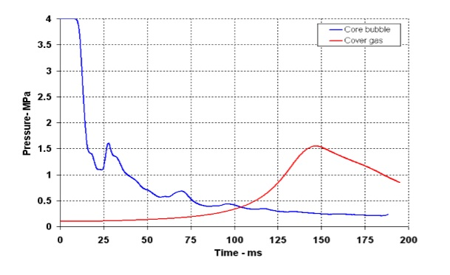

**Fig. 12a: Evolution of core bubble and cover gas pressure during the disassembly phase**



**Fig. 12b: Evolution of cover gas pressure during the disassembly phase**

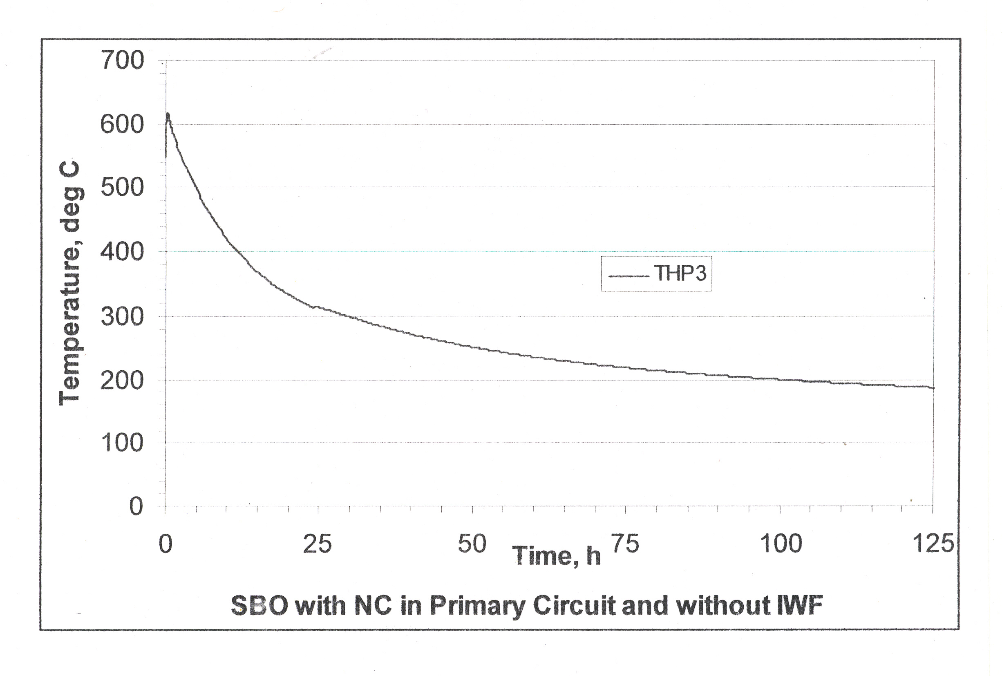

**Fig. 13: Evolution of hot pool temperature following a CDA**



**Fig. 14: Evolution of RS top plate temperature following a CDA (Roof slab cooling is assumed unavailable)**

rcb_temp.eps

**Fig. 15: Evolution of RCB Gas temperature due to instantaneous sodium fire**

rcb_pres.eps

**Fig. 16: Evolution of RCB Gas pressure due to instantaneous sodium fire**

**5. Simplified model of RCB source term estimation**

Before developing detailed models for the in-vessel and RCB source term estimation, to study the sensitivity and important phenomena in the release of RN, a simplified model has been developed to calculate the source term in RCB.

The conservative core damage scenario is assumed to arise from the Unprotected Loss of Flow event (ULOF) and bounding values are calculated. In brief, the scenario considered is as follows: loss of flow (tripping of both primary pumps) without SCRAM action leads to coolant boiling, positive reactivity addition, fuel over-heating and slumping of fuel mass under gravity. The fuel slumping model used to predict the accident evolution is very conservative and results in a reactivity addition rate of 10$/s, a further conservatism 65$/s reactivity addition rate is postulated at this stage. This reactivity addition rate leads to prompt criticality excursion resulting in a thermal energy release of 5500MJ before becoming subcritical due to fuel expansion. The resultant mechanical energy release is estimated to be 100MJ. The expanding core bubble consists of 54% molten fuel and 40% vapour. The core bubble during the expansion phase transmits the pressure to sodium and the cover gas. Since the core bubble is surrounded by sodium (~ 1150 t) which is a large heat sink, it can absorb all the heat energy of the core bubble with a time constant of ~0.8 s. During such a scenario, part of the radioactive fission product and fuel inventory is released from the core into the Reactor Containment Building (RCB), along with the coolant agglomerate. The release fraction of these isotopes depend on the nature of core melt, temperature of the molten corium, physiochemical properties of the elements and other driving forces.

**5.1 In-vessel source term**

The core to RCB release fraction depends on many phenomena like degree of core melt, sodium retention factors, vaporization from of RN from sodium free surfaces and physio-chemical properties of the isotopes. The important radionuclide depending on the similarity under accident condition, are divided in eight groups:

1. Noble Gases (Xe, Kr)
2. Halogens (I, Br)
3. Alkali Metals (Cs, Rb)
4. Tellurium Group
5. Barium, Strontium Group (Ba, Sr)
6. Refractory Metals (Ru, Mo, Pd, Rh)
7. Lanthanides (La, Y, Pm, Nd, etc.)
8. Cerium Group (Ce, Pu, U, Zr, etc.)

Literature indicates that the fraction of noble gas release is nearly total (100%). For volatile RN, iodine and cesium vapor contribution to the source term is very small 2-4% compared to liquid sodium aerosol contribution. For a complete core uncovery scenario, release fraction of 10% is given for I and Cs and 0.01% for low volatiles. The release fractions assumed from core to RCB for all the nuclides considered are given in Table 10.

**Table 10: RCB release fractions**

| **Isotope Group** | **Release Fractions** |
| --- | --- |
| Kr, Xe | 1 |
| I | 0.1 |
| Cs, Rb | 0.1 |
| Te | 0.1 |
| Sr, Ba | 0.04 |
| Ru | 1.0E-4 |
| Zr, La | 1.0E-4 |
| Ce, Actinides | 1.0E-4 |
| Na | 1\* |

[\*350 kg of Na is assumed to be ejected to RCB with factor 1]

**5.2 RCB Source term**

After the CDA, the RCB will be isolated based on radioactivity signals from area gamma and duct monitors. The ejected sodium will exothermically react with RCB air and assuming that all the available sodium (350kg) reacts instantaneously, pressure will be maximum of ~13kPa (gauge). The radio-nuclides (RN) released from the core are in the form of particulates, vapor and gases which are assumed to be uniformly distributed within the containment volume.

The source term in RCB depends on the release fractions from core to RCB, radioactive decay and various removal processes in RCB. A simplified model is used to compute the evolution of aerosol concentration in RCB. We assume that within minutes of the release, the agglomeration process would proceed to reach a stage which could be used to describe evolution of the aerosol concentration with an average size through the equation (1),

|  |  |
| --- | --- |
|  | (1) |

Where, n(t) is aerosol concentration as a function of time, R=PR+GR +TR and PR, GR, and TR refer to wall plating rate, gravitational sedimentation rate and thermophoretic removal rate. The removal rates PR, GR, and TR are given by,

(2)

(3)

(4)

The constants and typical values of the parameters are given in Table 11. Cc is Cunningham slip correction factor and its value is Cc=1.18 (from experiments)**.**

.

**Table 11: Parameters and their values for aerosol rate constants**

|  |  |
| --- | --- |
| **Parameters** | **Values** |
| Gravitational constant (g) | 9.8m/s2 |
| Floor Area (Af) | 1385m2 |
| Deposition wall area (Aw) | 16665 m2 |
| RCB volume (V) | 86146 m3 |
| Viscosity of RCB air (η) | 20.71E-06 N.s/ m2 |
| Shape factor (χ) | 1 |
| Density correction factor (α) | 0.5 |
| Boltzmann’s constant (k) | 1.38E-23 m2 kg s-2 K-1 |
| Temperature (T) | 342 K |
| Deposition distance parameter (Δ) | 0.118E-06 m |
| Temperature Gradient | 10000 K/m |
| Constant depending on particle and gas thermal properties (kT ) | 0.1 |
| RCB air density (ρg) | 1.0kg/m3 |

**Sodium aerosols size**

After the CDA, the reactor containment building is bottled-up with sodium and radionuclide aerosols. The RN removal rates are a strong function of the aerosol diameter. From experiments it has been observed that the sodium aerosols are in micrometer-size and they lie in the continuum region, while fuel and fission product aerosols are generated in sub-micrometer size and they lie in free molecular region. Hence the behavior of these different-sized aerosols is dominated by sodium aerosols and overall suspended mass concentration is governed by sodium aerosols. For this simplified calculation a median aerosol diameter of 0.5 μm is assumed. The removal rates for the aerosol size (diameter) of 0.5 μm is given in Table 12.

**Table: 12** **Removal rates(R in s-1) for Aerosols (r=0.25µm)**

|  |  |  |  |  |  |
| --- | --- | --- | --- | --- | --- |
|  | | | | | |
| **Aerosol** | **ρm(kg/m3)** | **Total R (s-1)** | **Gravitational sedimentation (Gr/R)** | **Wall plating (Pr/R)** | **Thermophoresis (Tr/R)** |
| Na2O | 2270 | 1.10E-04 | 0.0024 | 0.7801 | 0.2176 |
| Rb | 1530 | 1.10E-04 | 0.0016 | 0.7807 | 0.2177 |
| Ru | 12400 | 1.11E-04 | 0.0127 | 0.772 | 0.2153 |
| Sr | 2600 | 1.10E-04 | 0.0027 | 0.7798 | 0.2175 |
| Ce | 6800 | 1.10E-04 | 0.007 | 0.7764 | 0.2165 |
| Te | 6240 | 1.10E-04 | 0.0065 | 0.7769 | 0.2167 |
| Ba | 3600 | 1.10E-04 | 0.0037 | 0.779 | 0.2173 |
| Zr | 6506 | 1.10E-04 | 0.0067 | 0.7767 | 0.2166 |
| La | 6145 | 1.10E-04 | 0.0064 | 0.777 | 0.2167 |
| PuO2 | 11600 | 1.11E-04 | 0.0119 | 0.7726 | 0.2155 |

**Graph of few isotopes in RCB with time**

**6.0 Modeling of FPNG release from failed pins**

After CDA, the quantity of RN released is a function of number of fuel assemblies participating in the melt. The RN release from molten FSA had to be treated in detail for other RN except Fission Product Noble Gases (FPNG). For molten fuel SA the FPNG release is assumed to be total. However, it is important to assess the FPNG release fractions for FSA for which only clad might have failed during the CDA. The following description is for estimate of the FPNG released from failed pins after steady state operation.

The model considers retention, radioactive decay and transport within the fuel matrix. The effects on radionuclide release due to the thermal gradients, release from the grain boundaries, re-solution factors and the cracks in the fuel addressed. The isotopes considered for the calculation are given in Table 13.

Table 13: List of Radioactive Noble Gas Isotopes

|  |  |
| --- | --- |
| **Isotopes** | **Half life** |
|
| Ar-41 | 1.83 h |
| Kr-89 | 3.08 m |
| Xe-137 | 3.83 m |
| Xe-138 | 14.13 m |
| Xe-134m | 15.7 m |
| Kr-87 | 1.27 h |
| Kr-83m | 1.83 h |
| Kr-88 | 2.86 h |
| Kr-85m | 4.36 h |
| Xe-135 | 9.08 h |
| Xe-135m | 15.29 m |
| Xe-133 m | 2.19 d |
| Xe-133 | 5.2 d |
| Xe-131m | 11.9 d |
| Kr-85 | * 1. y |

Important steps in the calculation of the RN release from pellet to clad gap, i.e., Release to Birth Ratio (R/B) are,

1. Estimation of steady state production rate of isotopes in pellet using Bateman’s equation.
2. Given the pellet temperature profile calculate the diffusion coefficient for the fission gases.
3. Estimate of the free crack surface area formed due to thermal stresses in pellet. Estimation of gas bubble growth at grain corners and release through grain edge tunnel networks.

**6.1 Calculation of the RN diffusion from the fuel pellet**

The release of the fission products mainly occur through i) cracks formed due to thermal stress ii) through the diffusion of the fission gases through inter and intra grain boundaries. (refer figure) Hence, the total R/B can be given in terms of release from the cracks due to thermal stress and the release from the grain boundaries. The equation for the release from the fuel to the fuel-clad gap can be given as below [ref-2],

Where,

= Release to birth ratio from the fuel to clad gap

= The diffusive release from the grain edges and grain boundaries

= The release from the cracks formed due to the thermal stresses

= Effective surface area of the crack from which the fission gas releases to volume of a cracked body

= Effective surface area of the grain boundaries to total grain volume

D = Diffusion coefficient for the fission gas isotope

= Decay constant of the fission gas isotope

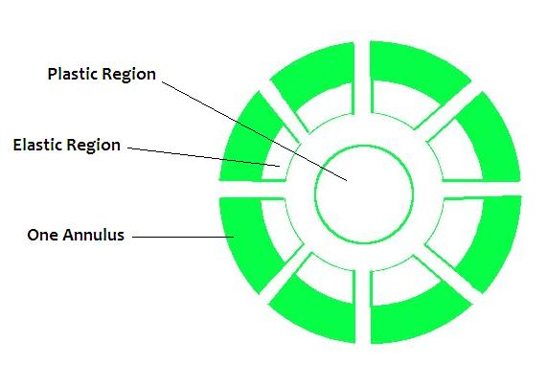

1. **Calculation of the surface area to volume of the cracks:**

Due to thermal stresses, the outer region of fuel pellet cracks. Hence, the fuel pellet can be assumed to be made of two regions 1) Plastic region whose temperature is greater than 1400 ºC, 2) The outer region where the fuel is cracked due to the thermal stress. Also these cracks are linearly proportional to the linear heat rate. [ref-Olander] Hence the fuel pin can be modeled as shown in figure 17.

**Figure 17: Schematic geometry of cracked pellet**

The pellet is divided in to ‘*n’* number of annulus and for each annulus, the is calculated.

1. **Calculation of effective area of grain boundaries**

After a short period of irradiation, formation of fission gas bubbles take place in the fuel grain. The formation of such (stable) fission gas bubbles saturate during reactor operation. Then, the unstable gaseous fission products diffuse to the grain boundaries, then to grain faces, and to grain corner and further to grain edges. The gas bubbles further aggregate around the junction of three grain edges. These grain edge bubbles coalesce to form a tunnel network. The tunnel network links with the open surface such as cracks, to release fission gas. The details of estimating (S/V) for grain corner bubbles can be found in [ref 4].

Combining the S/V ratio for crack and grain boundary, R/B for the fuel pin can be written as:

Where,

**6.2 Calculation of the temperature profile and the diffusion coefficient:**

The diffusion coefficient of a fission gas atom is temperature dependent and hence temperature profile along radial direction of the pellet is must (assuming there is no axial temperature variation in the pellet). The steady state heat distribution with internal heat generation is obtained. It is assumed that the heat generation is uniform and the heat diffusion equation is solved to obtain the temperature distribution. [ref walter]

The boundary condition for this equation is given as below:

1. at r = 0
2. at

Where,

T = Temperature in (K)

K = thermal conductivity (W/m.K)

Q = Uniform volumetric heat source

= radius at the outer surface of the pellet

= temperature at the outer surface of the pellet

The temperature dependent diffusion coefficient is estimated as follows., [2]

Where,

is the irradiation induced vacancy concentration

- fixed sink strength (~)

S - atomic jump distance (~m)

Z - number of sites around a point from which recombination is inevitable (~100)

- vacancy jump rate = s-1

K - defect production rate per atom (~2x10-4/s atom)

- Fission rate

* 1. **Calculation of the release fraction from the clad**

The formula is derived from Darcy–Weisbach equation for calculating the volumetric leak rates. The volumetric leak rate can be given as,

Where,

= pressure drop in the pipe

L = length of the pipe

D = hydraulic diameter

= density of the fluid

V = average velocity

A = area of rupture

= viscosity of the fission gas

= volume of the fission gas plenum

* 1. **Calculation of the radio nuclides released from the fuel**

The RN released to the fuel clad gap is estimated using the following rate equations, (i - denotes the ith isotope)

(6.1)

The R/B values are estimated as discussed in the previous sections. Assuming that all those RN released from pin reach cover gas, the rate of change of concentration in the cover gas volume can be given as below,

(6.2)

Where,

= Concentration of the radionuclide in the fuel-clad gap

= Concentration of the radionuclide in the cover gas

= Ratio of the released fission gas nuclide to birth of the radionuclide

= Release fraction from the fuel pin cladding

= Purging rate in the reactor cover gas

= Decay constant of the particular radionuclide

i = indicates the radionuclide index

After CDA since the cover gas circuit will be isolated, the S/V term in eq. 6.2 will be zero. The release coefficient in both equations 6.1 and 6.2 will be function of time reflecting the clad breach characteristics of the fuel pins after the CDA.

**7. Conclusion**

**REFERENCES**

1. **White, R.J., Tucker, M.O., 1983. A new fission-gas release model. Journal of nuclear materials 118, 1–38.**
2. **Yang-Hyun, K., Dong-Seong, S., Young-Ku, Y., 1994. Release of unstable fission products from defective fuel rods to the coolant of a PWR. Journal of nuclear materials 209, 248–258.**
3. **D.R. Olander, Nuclear Technology, 74 (1986), p. 215**
4. **Yang-Hyun, K., Dong-Seong, S., Young-Ku, Y., 1994. An analysis method for the fuel rod gap inventory of unstable fission products during steady-state operation. Journal of nuclear materials 209, 62–78.**
5. **Alan E Walter, Donald R Todd, Pavel V Tsvetkov, Fast Spectrum Reactors, 2012. doi:10.1007/978-1-4419-9572-8**